**ONLINE BOOK STORE**

**Project Team Name : Code Crackers**

**Team Members:**

1. Nishanth Pininti ( nxp141730)
2. Sailesh Kolla ( sxk145331)
3. Vikram Vepuri (vxv141530).

**Description:**

Online Bookstore is an e-commerce application designed such that the User can buy books directly from the website. Each User should register to login into the website and after successful registration and login, User will be given access to buy books from the website. User can also new credit card information during checkout.

Website is developed in a way of service oriented Architecture as each component in the website is loosely coupled and has its own functional service and every database operation is performed through Restful Web services.

**Technologies Used:**

**Client Technologies:** HTML5, CSS, Bootstrap, JQuery, JavaScript.

**Server Technologies:** PHP, Yii2 Framework, Restful Web services, MySQL, Elastic search.

**Compression**: Accept encoding – gzip, deflate

Content encoding – gzip

**Security Protocol**: TLS/SSL protocol

**Cache:** Mem Cache

**Web Architecture Diagram:**

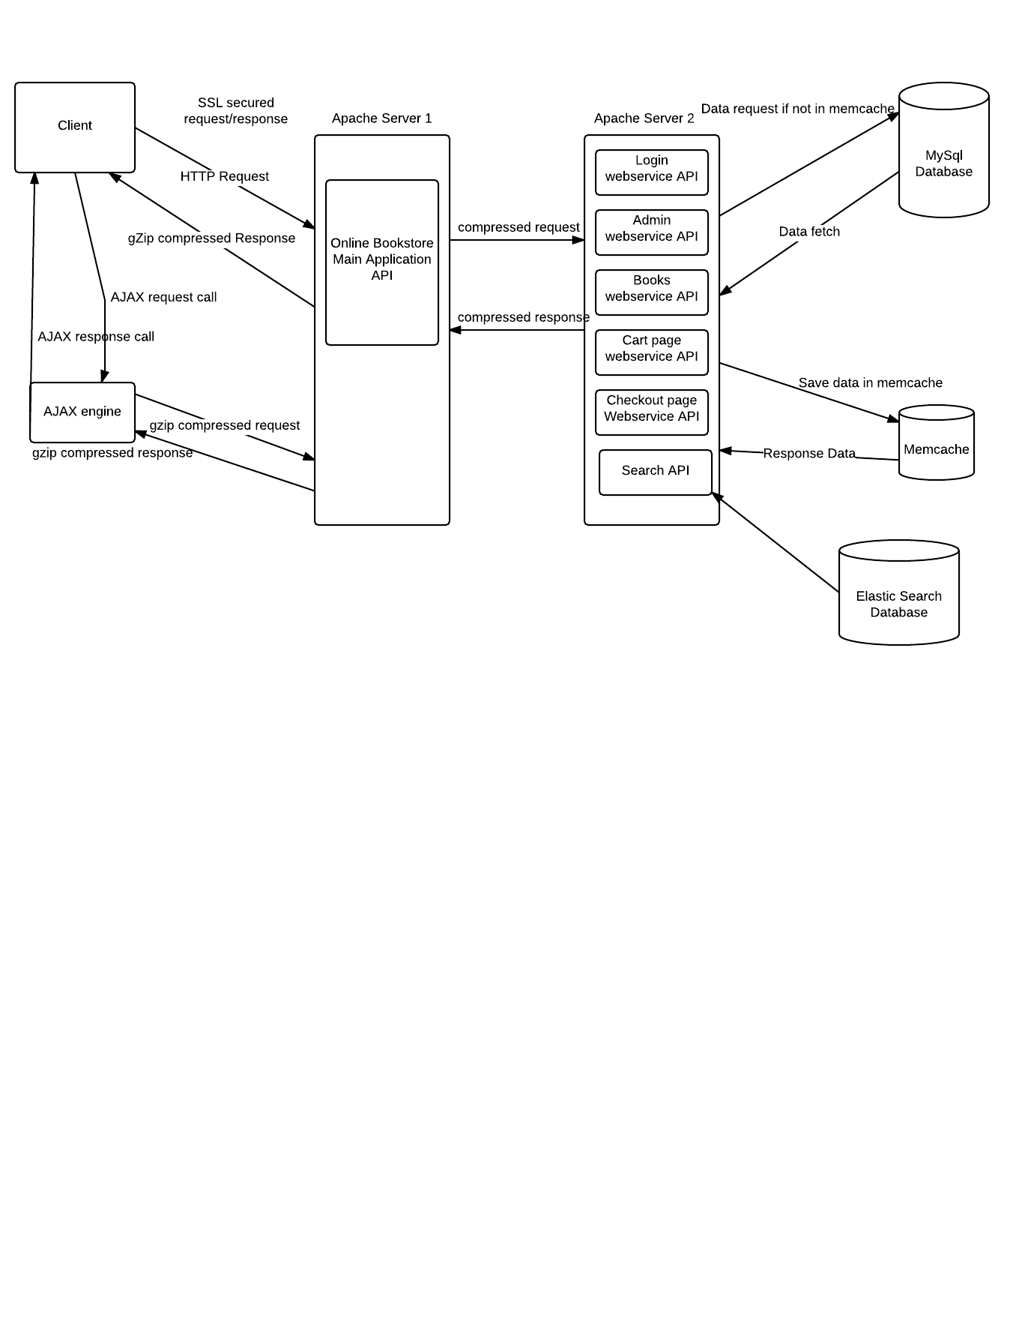

**Functionalities/Modules in website:**

1. **New user account registration:**

User who is new to the website will first register with the following customer name, phone number, email id, home address, and password. User can only register one account and each account must belong to one customer. There will be one unique email id and password for Admin. All these details will be passed to main Application API in server1 and then call Login Web Service API to store account information details.

1. **User login and logout:**

When user enters the login credentials to login into the site and all his details are validated at server side and call the Login Web Service API to check whether user is an authorized user to enter the site and will create session.

1. **Admin functionality:**

Admin will have default login and password provided by the website, when he will login with user email id as ‘admin@gmail.com’ and password as ‘admin’ to enter the website and enter all the fields of book details to insert into the book database via Book Web Service API.

1. **Book Search:**

All books can be searched by typing any word contained in the Book Title name in the search box which will go to Main application and will call Search API to fetch the data from Elastic Search Table.

1. **Add to/edit Shopping cart:**

After the User login into the site, User can add the books he likes to buy by clicking ‘add to cart’ button which will do an AJAX call to send the book details to main application API and then call CART Web Service API to insert the details into the Cart table.

1. **Checkout and place order:**

User can see all the book items added to the cart by fetching the data from a Cart API Web Service Call, and User is provided option to the delete books from the cart which in turn makes an AJAX call to CART Web Service API to delete from ‘cart’ table, User will have option to change quantity of each book. User can enter into Checkout page by clicking ‘checkout’ button where Checkout page will be displayed. User can enter the Credit card information and check the home address to deliver the book to and after clicking the ‘Place order’ button, all the book which were ordered will be inserted into the Database table via Checkout page Web Service API.

**Description of Open API’s - Web services (RESTful)**

1. **Login Web Service API:**

User after clicking the register button will make a web service call to the User Authentication Login API, which interacts with the MySQL DB and inserts the registration details in the database.

User after clicking the login button will make a web service call to the User Registration/User Login API, which interacts with the MySQL DB and checks if user exists in the database.

1. **ADMIN API:**

Admin after login into the website enters new book information and click store book details which will make a web service call to the ‘ADMIN API’, which interacts with the MySQL DB and Elastic search DB.

1. **BOOKS API:**

All the books available in the website will be fetched from ‘book’ Database table by calling BOOKS API after user successfully login into the website.

1. **Search API:**

User after entering the keyword (book author or book title) and clicking the search button will call ‘search API ‘and fetch the books from Elastic search DB.

1. **Cart page API:**

User after clicking the ‘add to cart’, an AJAX call will be made to call Cart PAGE API to insert into Cart table, and after user enters into the ‘cart’ page, all the books in the cart of the particular user will be fetched by calling CART page API.

1. **Checkout Page API:**

User after placing the order will call ‘Place order API’ and store the order details in MySQL DB. User will also have option to enter credit card information which will be stored in the billing database table by calling ‘Place order API’.